**Hibernate**

1. If you do not want to save any property in database use static or transient keyword in the property like private **private static** String name; or **@Transient** annotation.
2. @Temporal – Use this annotation if we want to format date. By default java.util.date stores timestamp in database. Use @Temporal(TemporalType.***DATE***) for storing just the date part and there are other types in enumeration “TemporalType”.
3. @Lob - there This is used for defining the long data types in java like clob etc. For ex: Hibernate make any String type field as 255 char long by default. But if we want to store more that this capacity, we use big data types.
4. @GeneratedValue(strategy=GenerationType.***AUTO***) – Used to define the primary key of the table.
5. Entity vs Value Objects – table. There are two concepts in Hibernate. Entity and Value objects. Entity is the main class. Value objects are classes which give value to an Entity class.

For Ex:- In below case, User class is Entity and Address class is Value object. As Address does not have it’s own entity. It will have meaning only with in User class.

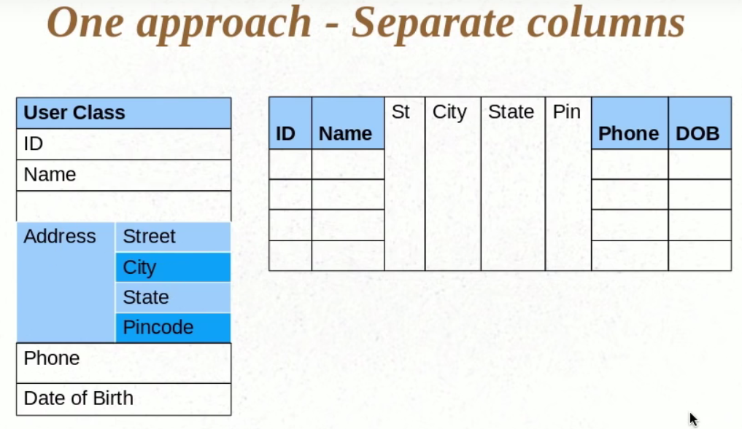

1. @Embedded & @Embeddable – Annotations are used to denote Value objects. If you have user class and address class is used as member variable in user class. And you want to store both this information in same user table in database, You can use these annotations.
2. @EmbeddedId – This annotation is used if your class does not have primitive type but an object.

For Ex:- If we have User object and we have UserName property as it’s member variable which hold this @Id attribute. And we want to use this id in user object.

1. @AttributeOverrides & @AttributeOverride- These annotations are used if you have two objects of same class defined as member variable in entity class. In this case we can not use these same fields to be created as columns. So to differentiate these while creating the columns in database,we use these annotations.

@Embedded

@AttributeOverrides({

@AttributeOverride(name="street", column=@Column(name="HOME_STREET_NAME")),

@AttributeOverride(name="city", column=@Column(name="HOME_CITY_NAME")),

@AttributeOverride(name="state", column=@Column(name="HOME_STATE_NAME")),

@AttributeOverride(name="pincode", column=@Column(name="HOME_PIN_CODE")),

})

**private** UserAddress homeAddress;

@Embedded

**private** UserAddress officeAddress;

1. @ElementCollection – To use collection in your entity class.
2. @JoinTable - If you have to change the name of collection attribute, Use this annotation.

@ElementCollection

@JoinTable(name="USER_ADDRESS")

**private** Set<UserAddress> listOfAddress = **new** HashSet<UserAddress>();

1. @JoinColumn – To rename the column name in Join table.

NOTE:- All the above annotations are JPA standard. Means if you change any other technology which supports JPA, will use the annotations and we do not need to change the code.

1. @CollectionId – This is hibernate specific annotation. This is not JPA standard. This is used to define primary key in the collection entity.
2. @GenericGenerator - This is hibernate specific annotation. This is not JPA standard.This is used to define Generic Generator.

@GenericGenerator(name="hilo-gen", strategy="hilo")

@CollectionId(columns = { @Column(name="ADDRESS_ID") }, generator = "hilo-gen", type = @Type(type="long"))

**private** Collection<UserAddress> listOfAddress = **new** ArrayList<UserAddress>();

1. **Lazy Initialization vs Eager initialization –** In Lazy, Hibernate loads all the first level member variables of the Entity and then it initializes the list only when we access it. This is default configuration.

Eager Initialization is just opposite of this. i.e to load everything at the first shot. We should do it only if it is really required as it is going to take a lot of resources.

1. **Proxy Class –** only Whenever we do session.get on user class, Hibernate will create a proxy class and instead of giving you the instance of User class directly, it will cleverly create a proxy user class and send it’s instance back to you. This proxy user class will be sub class to your main user class.

Session session = **this**.sessionFactory.getCurrentSession();

UserDetails user = (UserDetails) session.**get**(UserDetails.**class**, id);

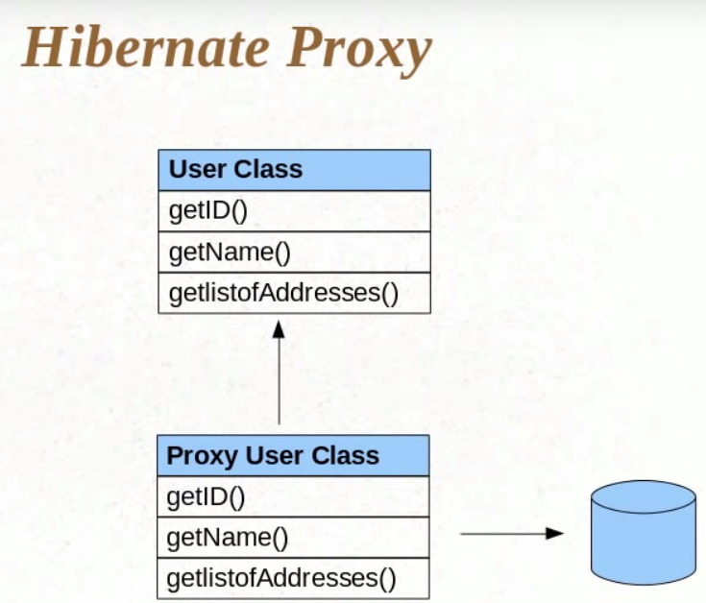

1. **@OneToOne –** This annotation is used to establish one to one mapping.

In below example one user can have one vehicle.

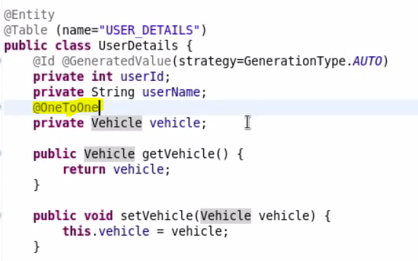

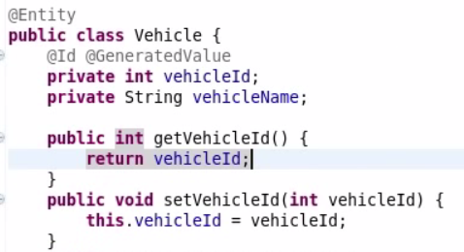

Tester class:

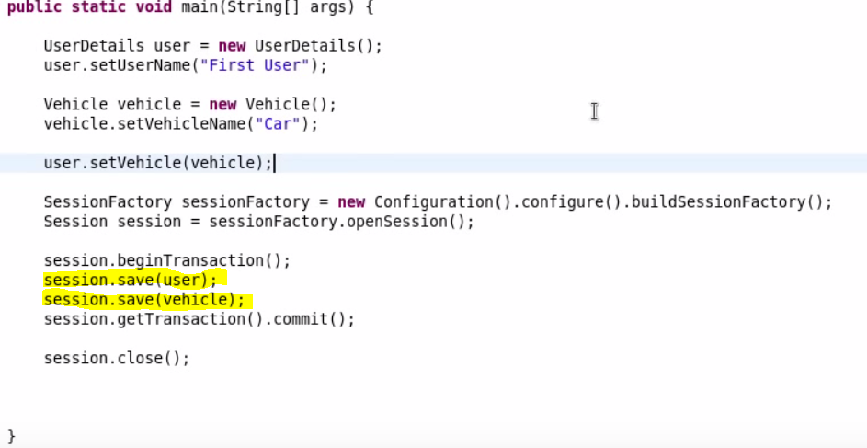

Output:

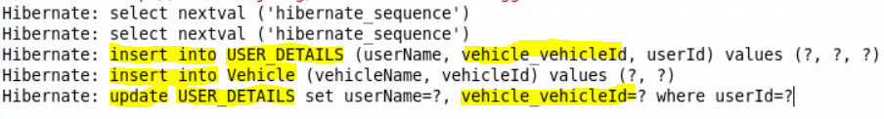

1. @JoinColumn – Using this annotation we can give column any given name.

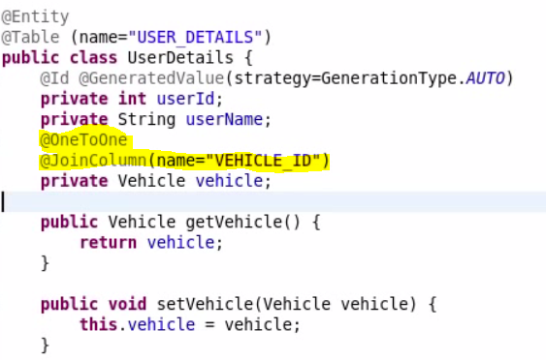

Output:

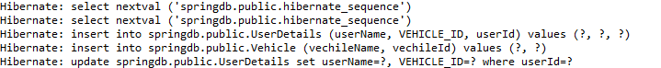

1. **@OneToMany -** This annotation is used to establish one to many mapping.

In below example one user can have one vehicle.

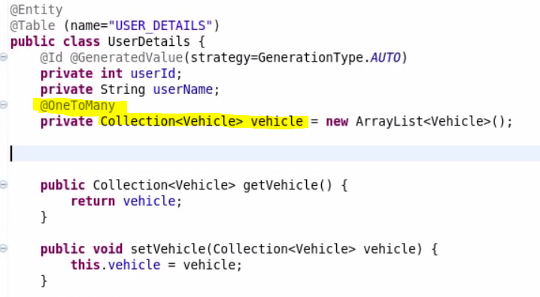

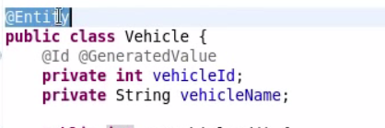

Tester:-

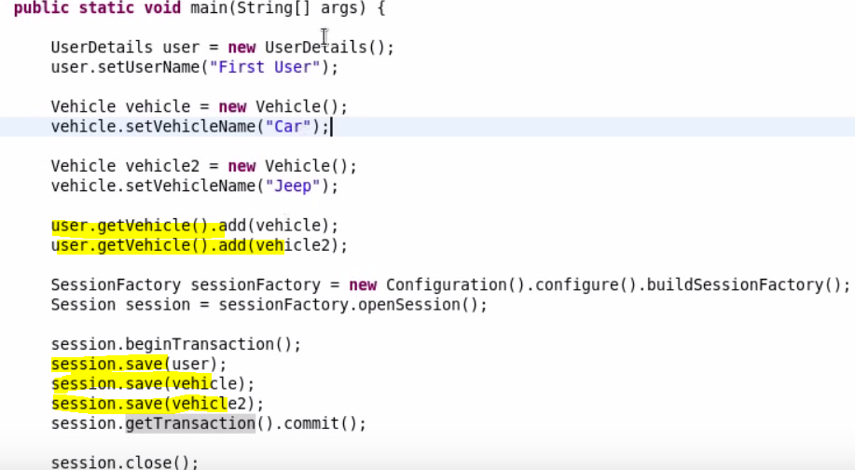

**Output:- Hibernate will add user and both vehicles in respective tables. But note that it also created one additional table “USER_DETAILS_VEHICLE” table. This table contains the cross reference for both tables. i.e mapping for user_id with vehicle_id.**

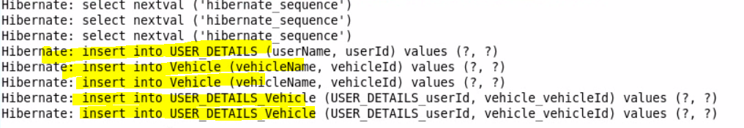

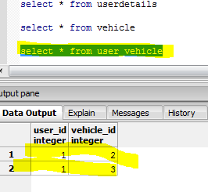

1. **@JoinTable/@JoinColumn/inverseJoinColumns – These are used to define the new name. i.e rename the default name.**

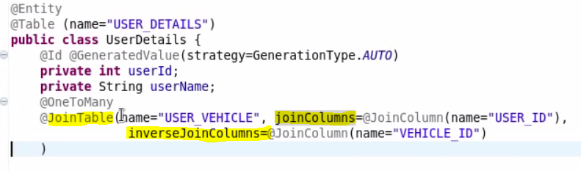

**Output:-**

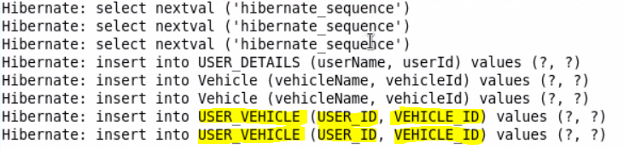

1. **@ManyToOne – This is same as above (One To Many). This will establish Many to One relationship.**

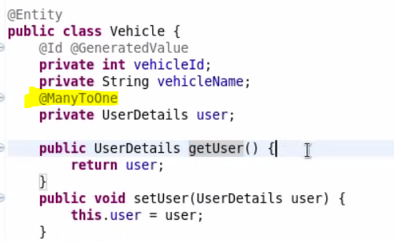

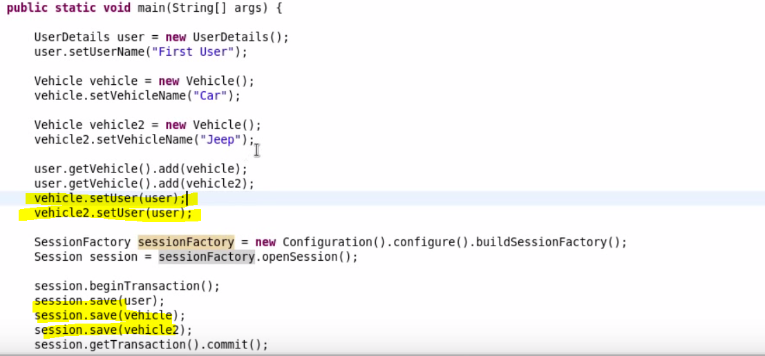

1. **mappedBy Property:-** This is used in OneToMany or ManyToOne type of relationships. Note that in above cases, i.e in Default case, Hibernate will create a separate cross reference table for mapping user_id with vehicle_id. If we do not want Hibernate to create a separate table and have that reference in vehicle table, we use this mapped by property.

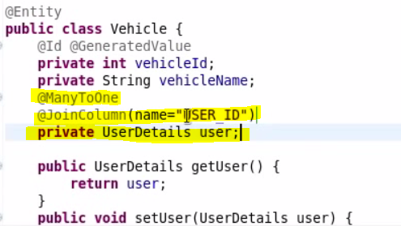

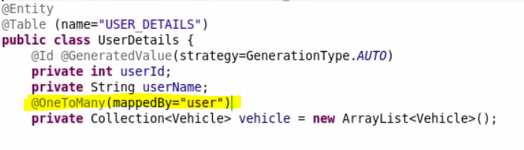

**Output:- Please see no new table created. Instead hibernate created a new column in Vehicle table called USER_ID where it will maintain relationship os one users-> many vehicles.**

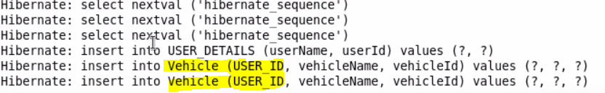

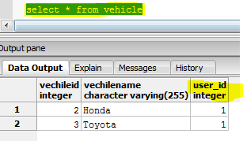

1. **@ManyToMany – This establish many to many relationships.**

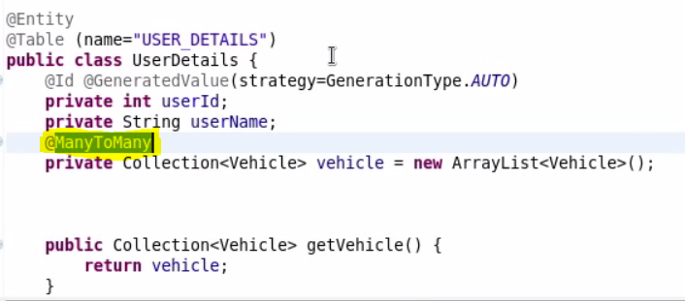

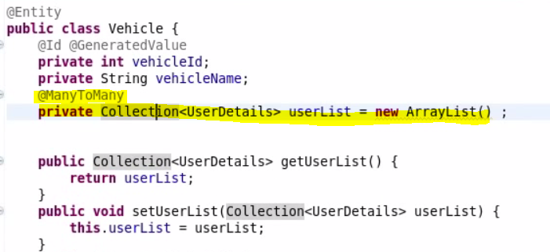

Tester:-

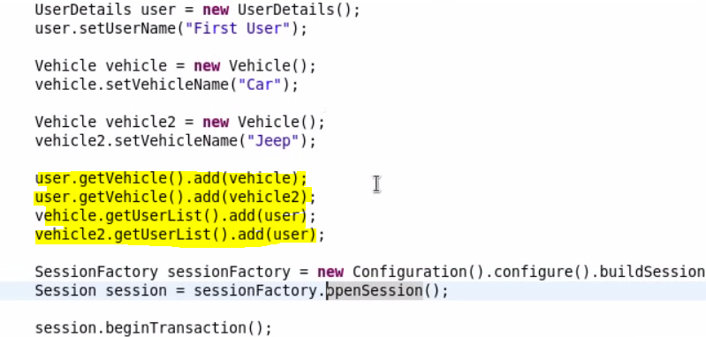

Output:- Here Hibernate created two relationship tables. One is “USER_DETAILS_VEHICLE” and other one is “VEHICLE_USER_DETAILS” table. It is having the same relationship so this is redundant tables holding same cross reference data.

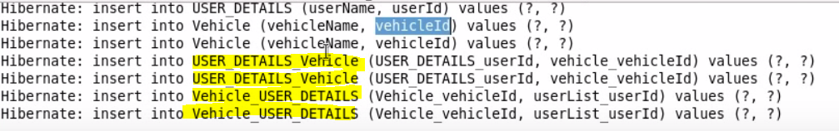

**Database:**

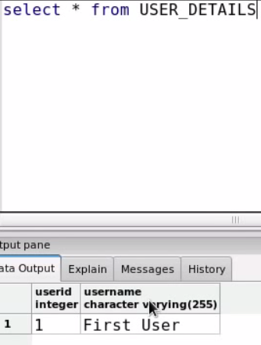 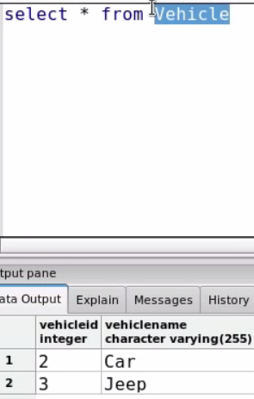 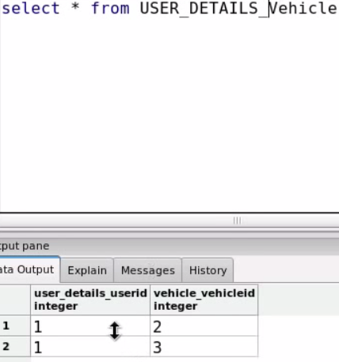 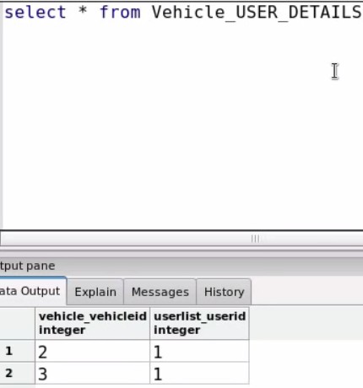

So data in “USER_DETAILS_VEHICLE” and “VEHICLE_USER_DETAILS” table is redundant. This we DO NOT want to happen.

So we want to happen only one mapping. That we achieve by “mappedBy” property.

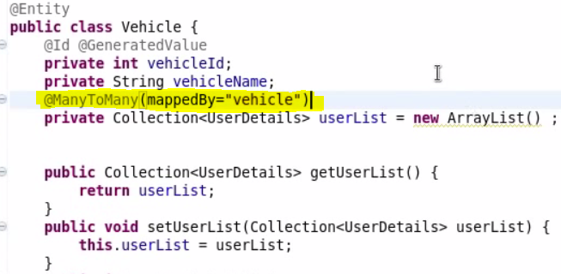

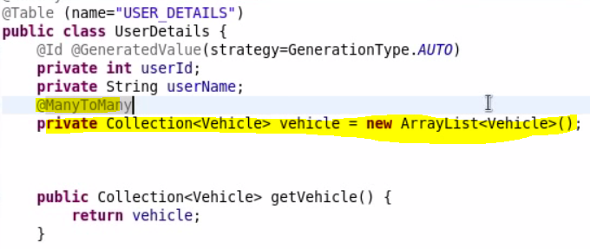

**Output:-** here we note that Hibernate created only one reference table. Because Hibernate created Many to Many mapping only for “UserDetails” table but not for “Vehicle” table. This is because we have defined mappedBy property in Vehicle class.

**Note:**- If we have to rename default names of this mapping class “USER_DETAILS_VEHICLE”, We need to define the @JoinColumn mapping in UserDetails class which that is the class which generated this mapping and created this class.

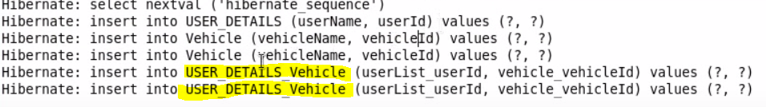

1. **mappedBy –** This will do the reference table mapping only one side.

@ManyToMany(mappedBy=”vehicle”)

**private** Collection<Vehicle> vehicle2 = **new** ArrayList<Vehicle>();

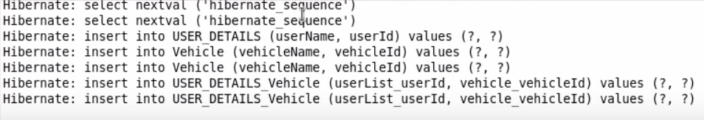

If we do not give this tag. It will have bidirectional mapping. Which is basically the same and reduntant.

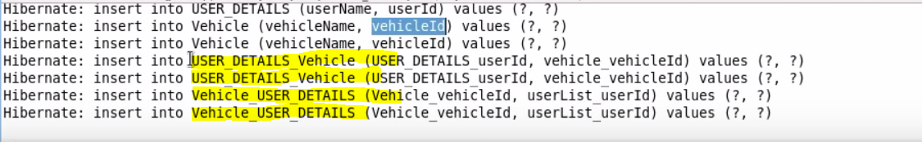

1. **@NotFound –** This annotation is used in scenarios where any Vechicle does not have an user account. In this case there will not be any getter/setter for UserDetails in Vehicle class. So Hibernate will throw exception.

To Ignore this Exception, We use this annotation.

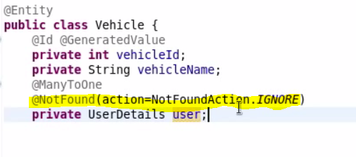

1. If You do not provide @Transactional annotation in service method implementation, You will get this exception.

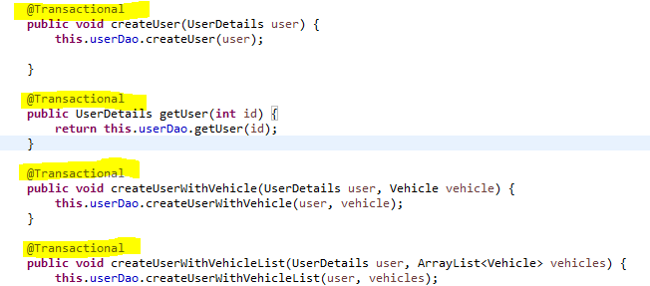

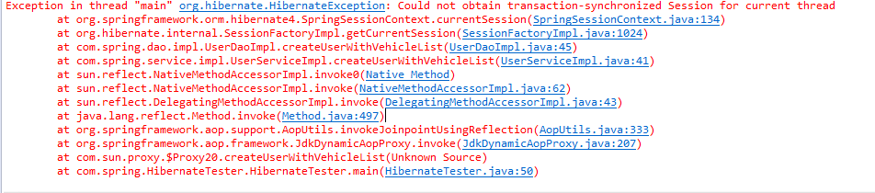

1. **Hibernate Collection:- Hibernate uses its own collection framework.** 
   1. **Bag Semantic - List/ArrayList**
   2. **Bag Semantic with Id - List/ArrayList**
   3. **List Semantic - List/ArrayList**
   4. **Set Semantic - Set**
   5. **Map Semantic - Map**

**Difference between Bag and List is that List can be Ordered. You can have an sorted list. In bag it does not matter in which order you get the data.**

1. **Cascade:- As you can note in the below main method that even if we set the reference of Vehicle to User object. Still we need to save both User and Vehicle object separately using session.save method. Why Hibernate is doing so, It should save the whole Object tree structure. I should be able to save user object with it’s Vehicle hierarchy by just saying session.save(user). This can be done by Cascade.**



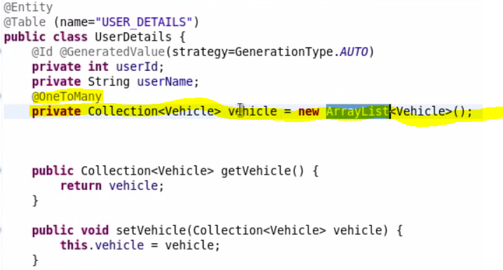

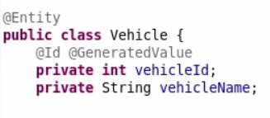

**Tester:-**

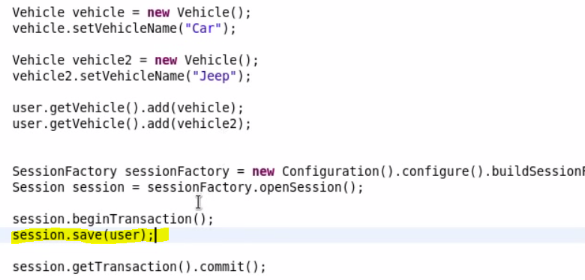

**If you try this to run this and save the user object with out calling session.save(vehicle) & session.save(vehicle2), Hibernate will throw an exception.**

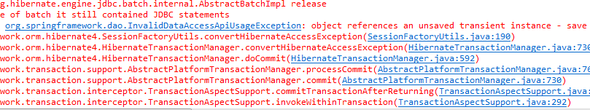

**To solve this we use this structure and use mappedBy:**

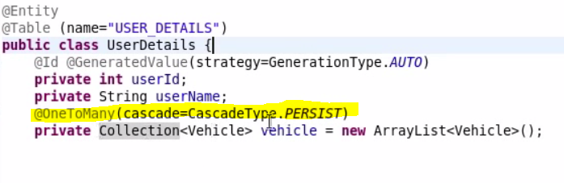

**Use session.persist instead of session.save to make this work.**

Output:- Now we can just use session.save(user) and it will save vehicle object as well. You do not need to specifically call session.save(vehicle).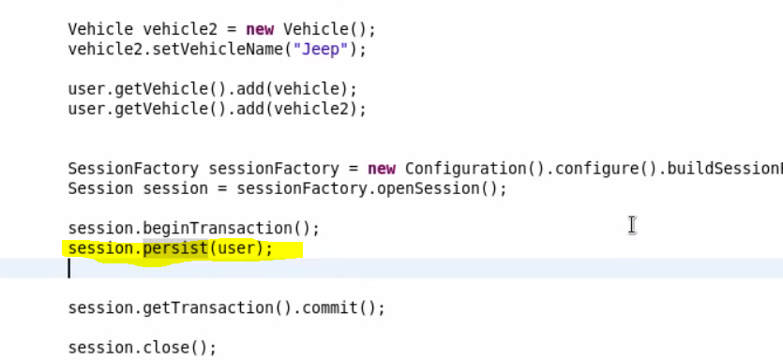

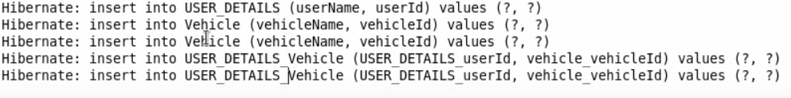

1. **Inheritance:-**

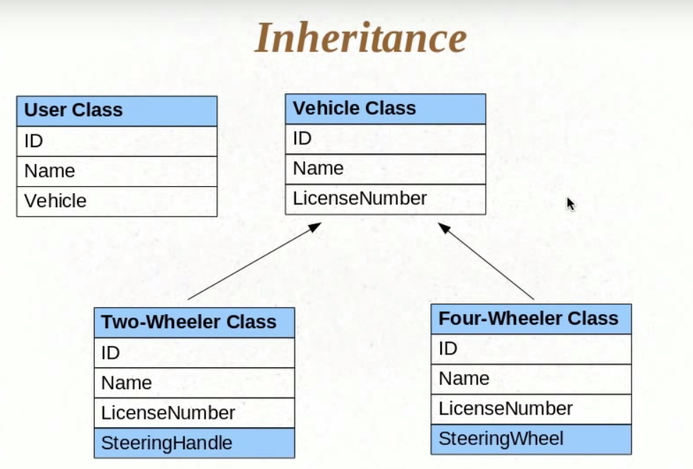

**In the following example we created one parent class Vehicle and two of it’s subclasses. FourWheeler and TwoWheeler.**

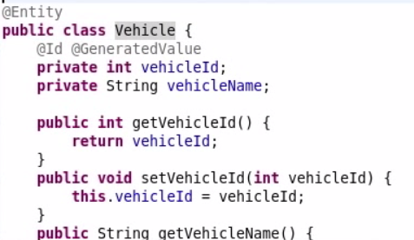 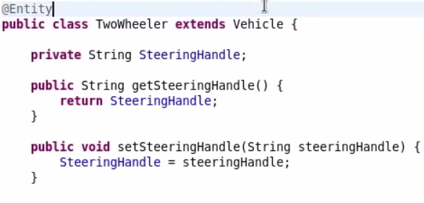

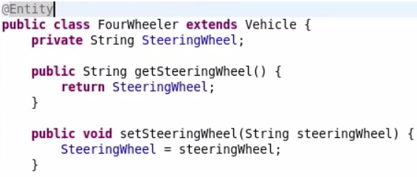

**Now if we save all three objects.**

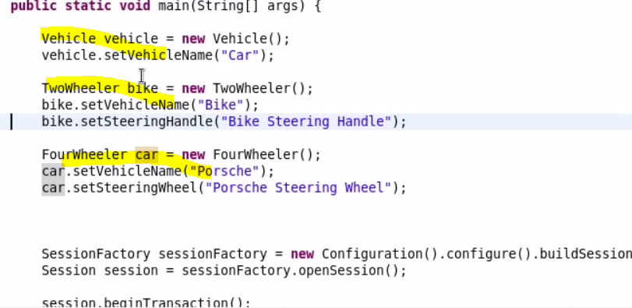 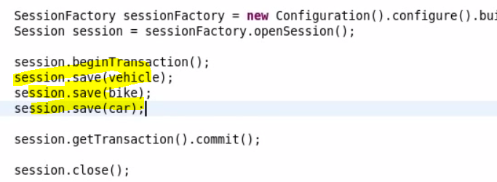

**Output:-**

As you can see Hibernate has not created separate tables for FourWheeler and TwoWheeler classes even thought we have marked them as Entity classes. Hibernate by default implemented a strategy for Inheritence called “Single Table Strategy”. Which means no matter how you have defined the inheritence hireracy, Hibernate will save all these objects in the single table.

So in this case, all the suclasss of Vehicle class gets added into Vehicle table.

Dtype- Will have class name. This is called as “Discriminator”. This can be used to identify the type of objects. This will tell which class that row belongs to.

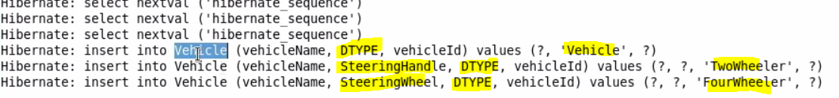

**Database:**

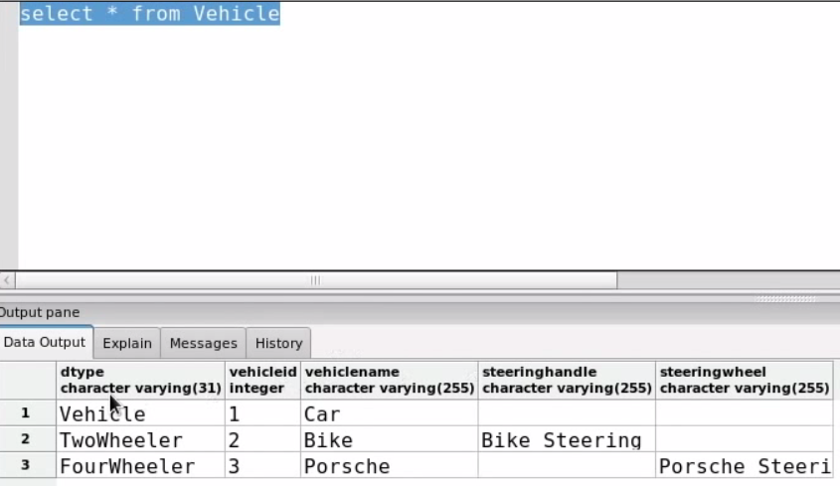

1. **@Inheritance and @DiscriminatiorColumn** : - If we want to control the Inheritance Strategy and Discriminator column, we can use @Inheritance and @DiscriminatiorColumn annotation.

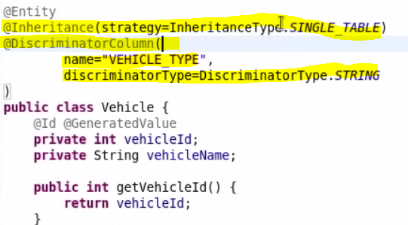

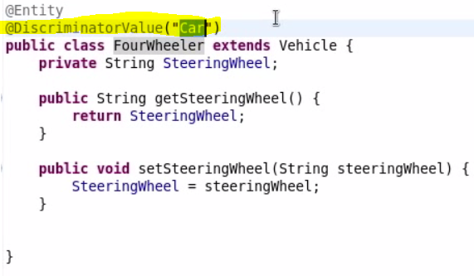

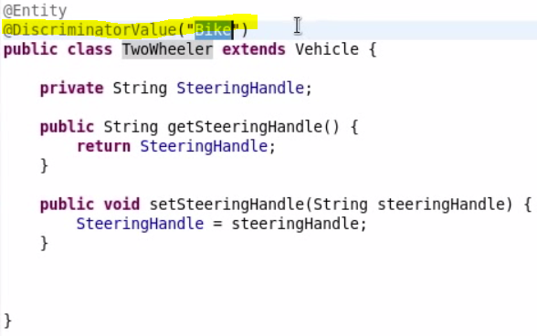

Output:

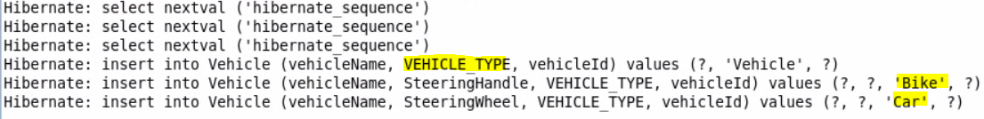

Database”

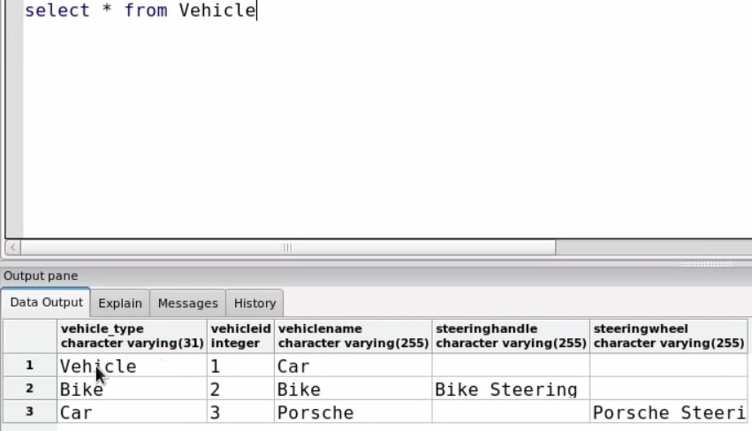

1. Other strategy are

@Inheritance(strategy=InheritanceType.TABLE_PER_CLASS) – Insert data in respective tables. But data will be reduntant as vechicle id and vehicle name will be stored in Two Wheeler and Four Wheeler tables as well.

@Inheritance(strategy=InheritanceType.***JOINED***) – In this no duplicated value will be added. Here vehicle id and vehicle name will only be stored in Vehicle table and Four Wheeeler and Two Wheeler related information will be added in their respective tables.

1. Session.save(user) – To save user.
2. Session.update(user) – To update user.
3. Session.delete(user) – To delete user.
4. **Transient/Persistent/Detached objects:-**

**Transient Object:-** This is the object when Hibernate does not even know about the object. Like you have created an object and didn’t send it to Hibernate’s session to perform any operation.

**Persistent Object:-** This is when we send the object to session like in below screen shot we are calling session.save(user). Now user is in Persistent mode. Any changes made after this will be logged in the database. This object is now in Hibernate’s control and Hibernate will track all it’s changes and save them to database.

**Detached Object:-** Detached object is similar to Transient object in the sense that hibernate is not going to track it’s changes. Object will go in Detached state after **session.close** and Any changes made after will not reflect in database.

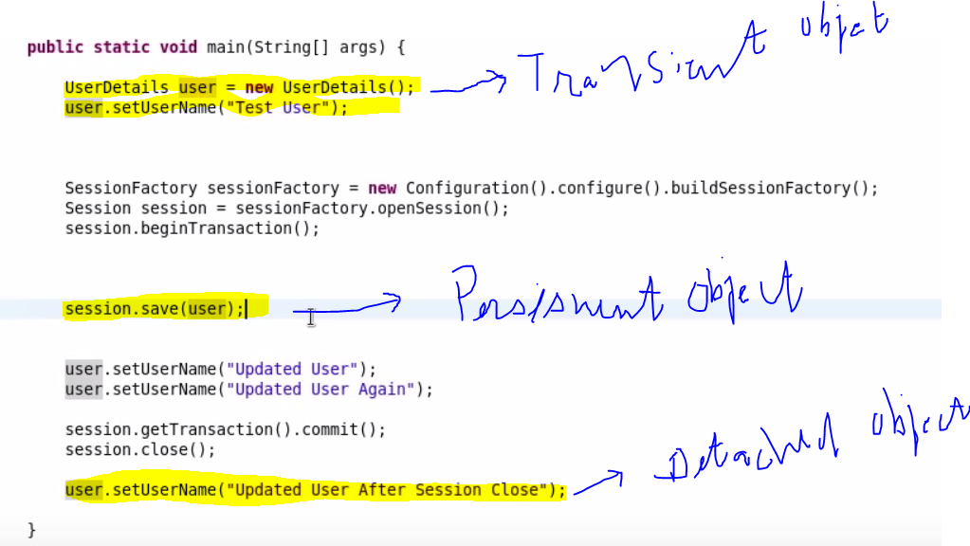

In the above screen print we are calling user.setUserName after session.save(user). This call will trigger an update call to user table. So any changes made after session.save will be tracked by Hibernate and updated in the database. Hibernate intelligently update the changes. Like in below console we can see only one update statement is logged even though we are setting the user name twice. It is taking the last changes made to user object and save only that information.

**Output:-**

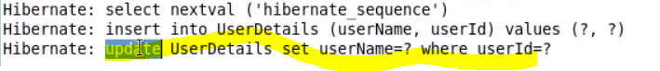

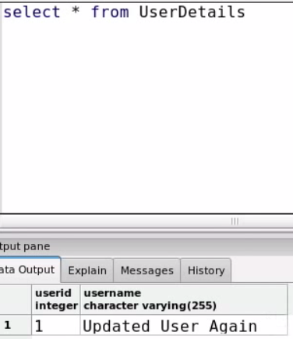

**Object States Flow in Create Operation.**

First we create an User object, It is in Transient state. Then we call session.save. Now it’s in Persistent state. Once session is closed, It goes to Detached state.

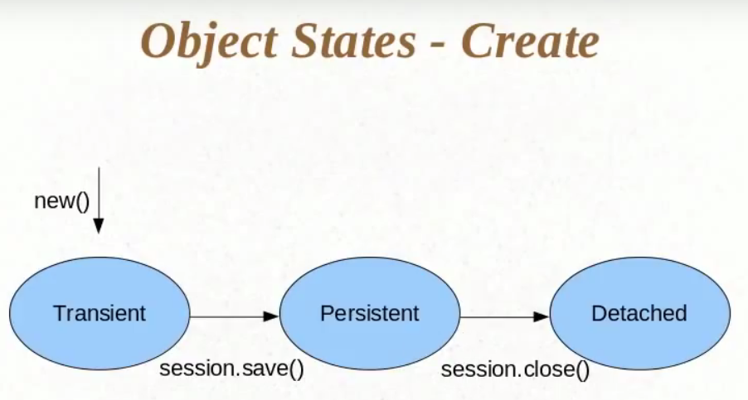

**Object States Flow in Read/Update Operation**

Here we call session.get(Object.class, id). Now we get an object from object based on the id and object is now in Persistent state. You do not need to call update as any setter operation you perform on this object will go to the database.

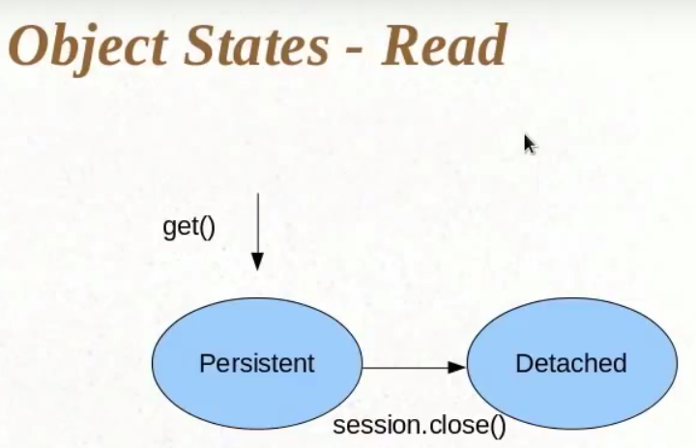

**Object States Flow in Delete Operation**

Here when we call session.delete(), Hibernate will delete the data from database. That’s why object goes to Transient state. Because for object to be called on Persistent state, it’s database representation has to be there. But delete would have deleted the data from databse.

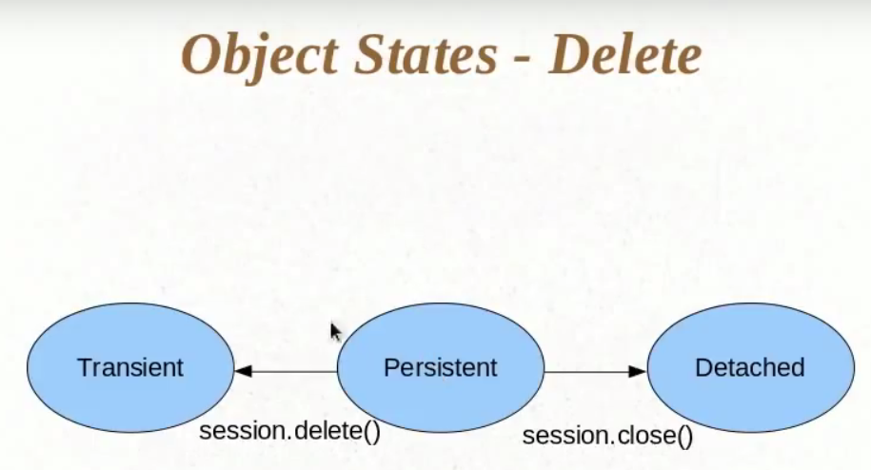

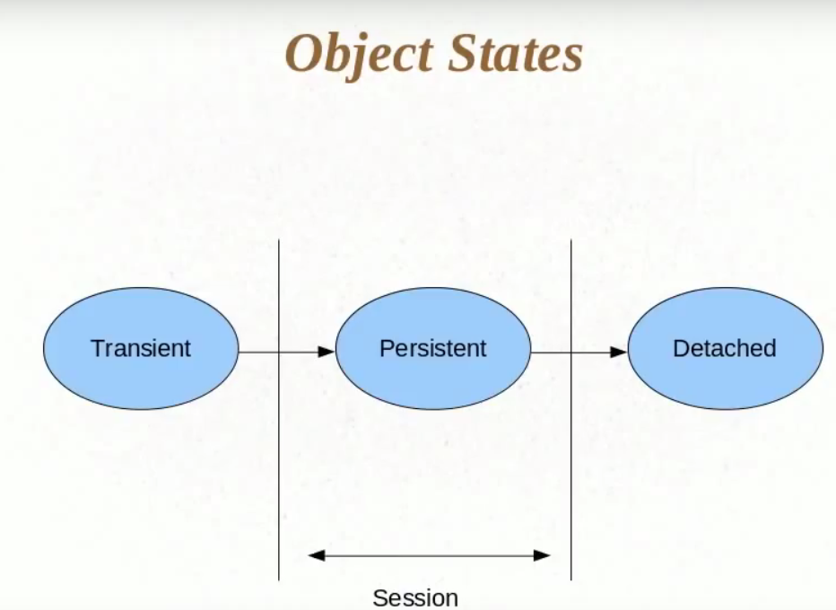

1. How can we send object from **Detached** state to **Persistent** state.

In some scenario we need to convert an detached object back to Persistent object. As in the below screen shot, we have one scenario where user see the list by DB fetch and then perform some modification and save it back to batabase.

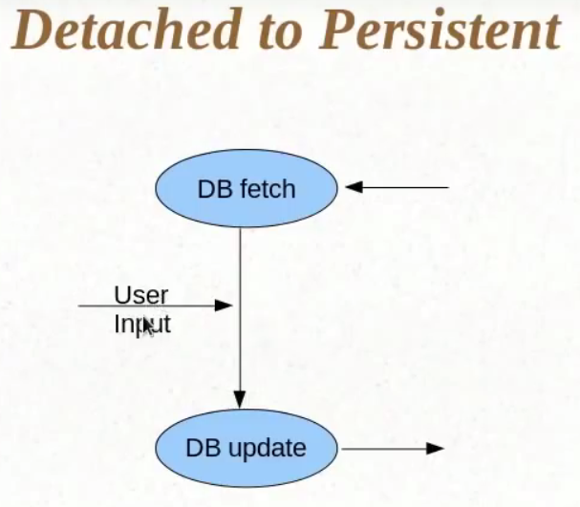

In below example, we get user records and closed the session. Now user object is in detached state. Now we made some changes in the user object by changing it’s name. and opened another transaction and session and make a call to session.update(user). Now object will go from detached state to Persistent state and data will be saved to database.

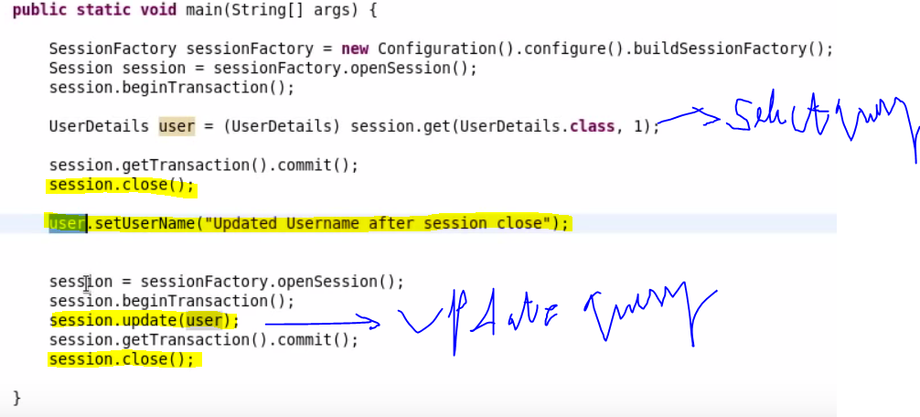



Database:-

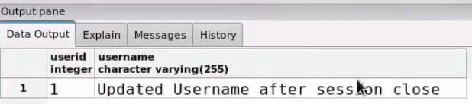

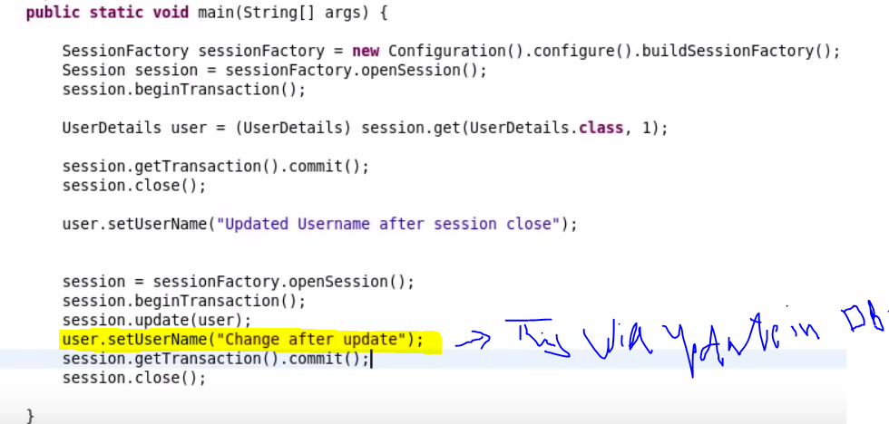

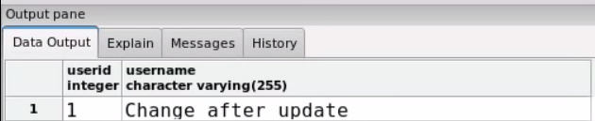

1. @org.hibernate.annotations.Entity – This annotation will first trigger select query and if there is a change in the user data, then only it will trigger Update query. If there is no change in user object, it will not trigger update query.

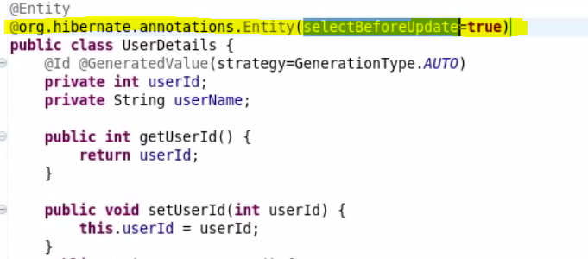

Ex:- No changes in User object.

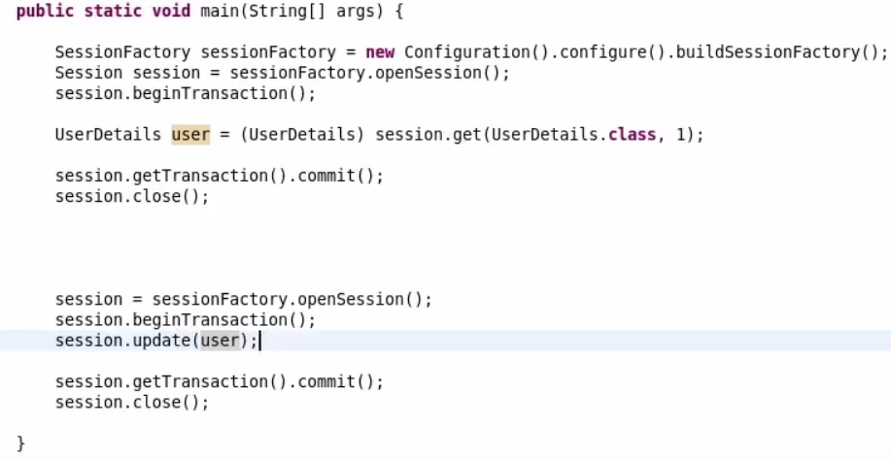

See there are two select statements in log. First one is from session.get and other one is from session.update. No update statement as there is no change in user object.



Change in user object:-

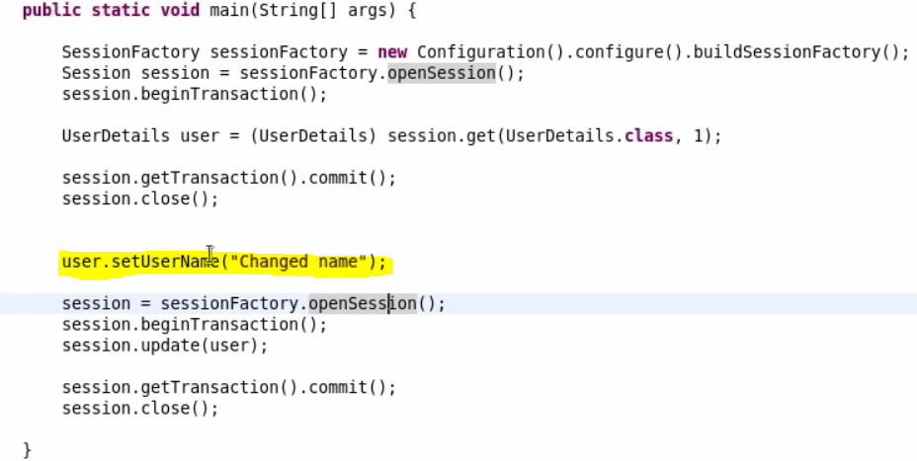

This time we changed user object, Update will be triggered.



1. **Pagination in Hibernate:-**

Query.setFirstResult(5) – Hibernate will pull records from 6th row.

**Query.setMaxResults(4) –** Hibernate will pull 4 records.

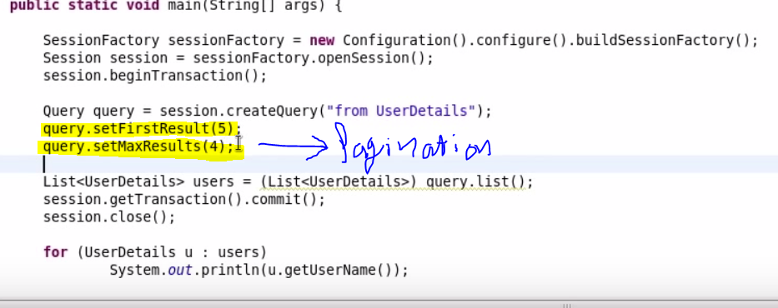



1. **@NamedQuery –** This annotation is used to define HQL queries on Entity class itself.

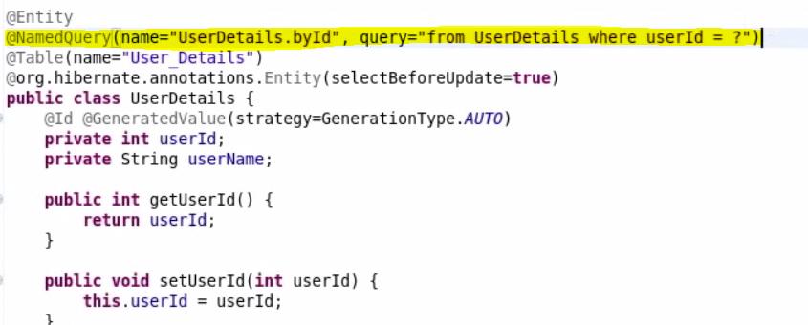

**Tester:-**

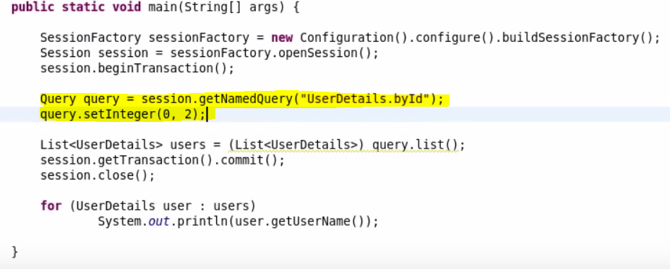



1. **@NamedNativeQuery –** This annotation is used to execute any native SQL query. You can run any stored procedure by it as well. Use this only wherever HQL is not an option.

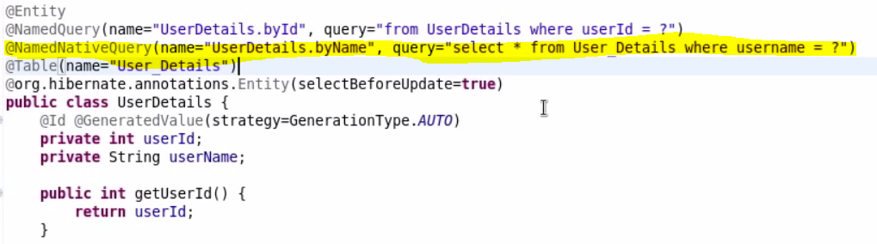

**Helper:-**

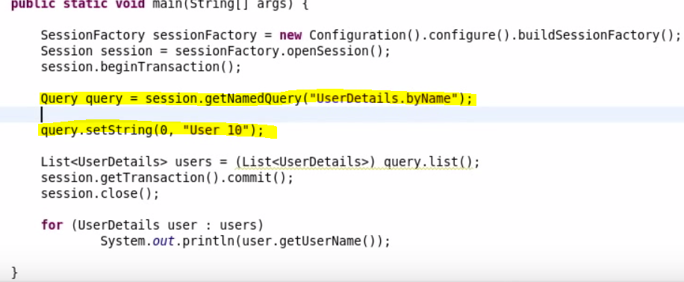

**Output:-**



1. Example – This is used to get the list of users satisfy this example. If you pass NULL or Primary key property in Example object, it will return all values from database. Other than that hibernate will consider other properties in Example class.

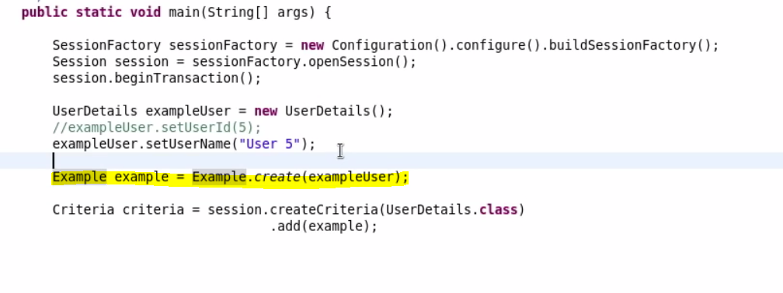



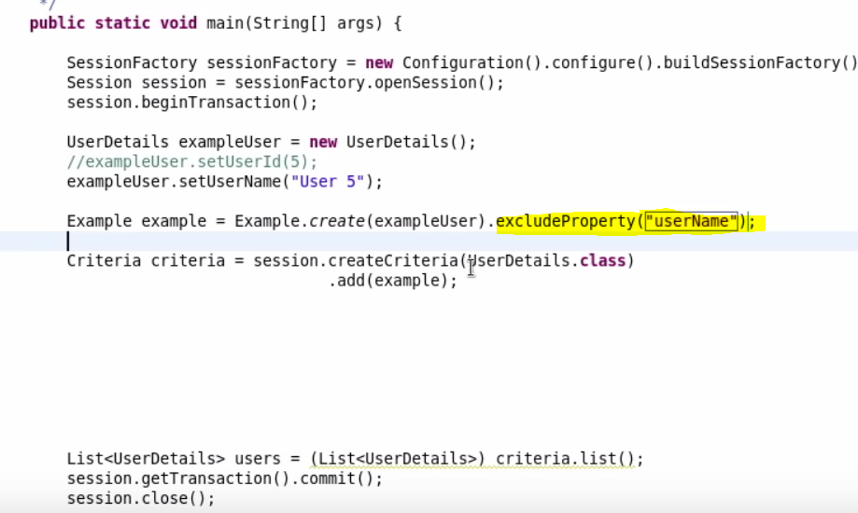

ExcludeProperty will exclude this property from result set.

1. EnableLike method – Below example will work like this. **Select username from userDetails where username like “User 1%”;**

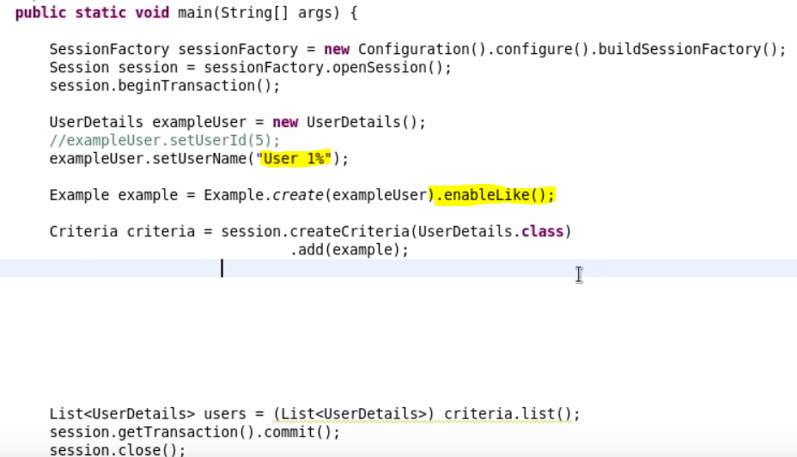



1. Projections – This will work as Aggregate functions.

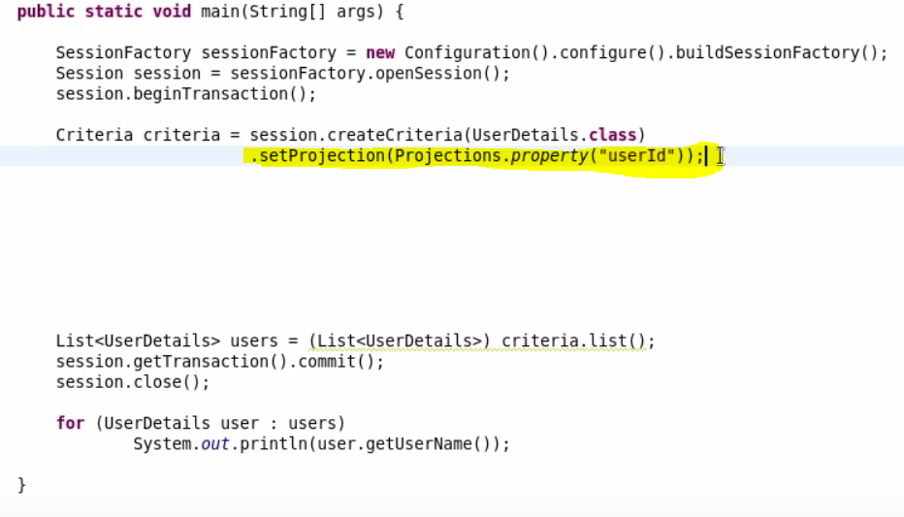

1. **Query By Example –** This is used to query based on setting an Example. This can be useful in those scenario where we do not want to add different criteria and instead of it, we want to set everything in an object.

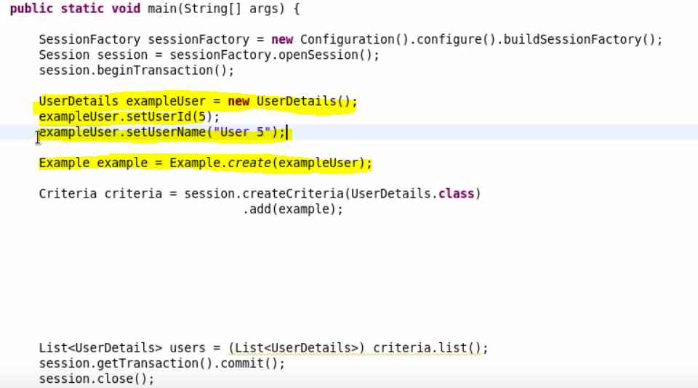

Here the condition is if you set only primary key property or NULL property, Hibernate will return you all the results and not the requested one. You have to give any other property to make it work.

Passing Primary key property.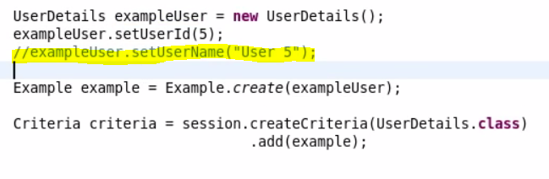

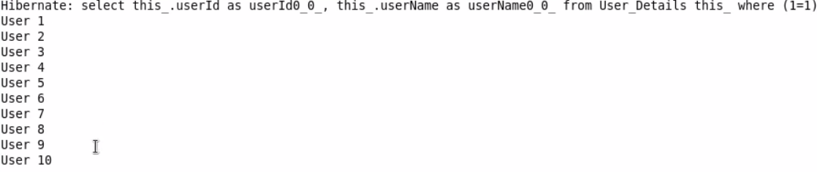

Passing any other property (Other than NULL or Primary Key)

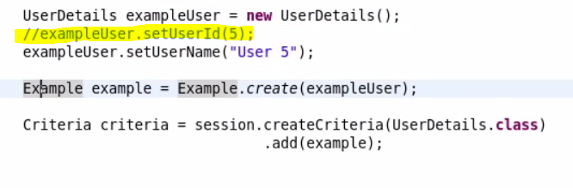



1. **Caching in Hibernate:-**

There are three type of caching in Hibernate.

1. **First Level Cache –** This is session object level cache. So if we execute two session.get with the same session object and session is not closed. Hibernate intelligently execute only one select statements because data is not modified. Even if you modify the data, Hibernate will only execute one select statement.

First Use Case:-

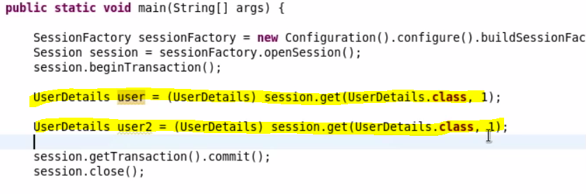



Second Use Case:

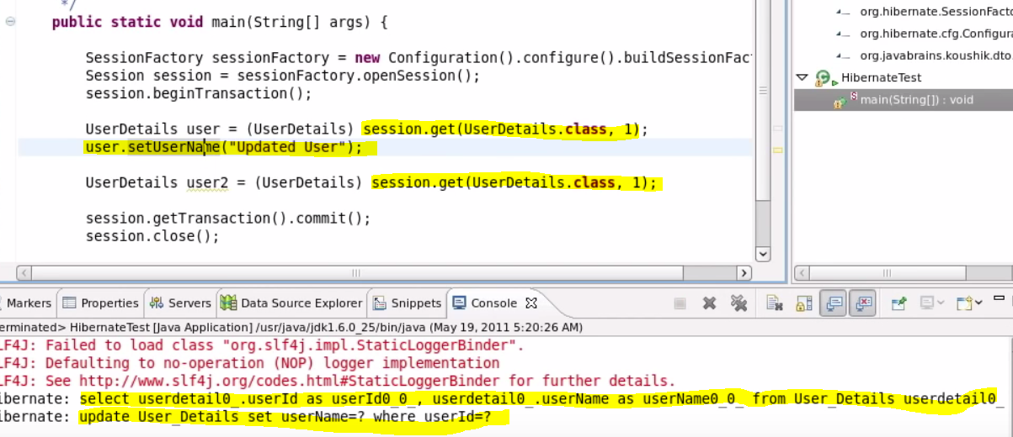

Third Use Case(Two Different Session) –

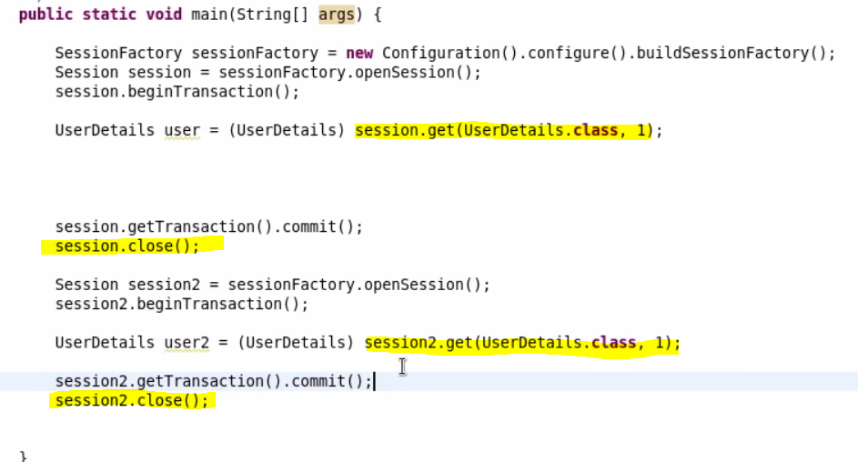



1. **Second Level Cache –** We can configure second level cache if we want to apply it on Session Factory level. It means if Hibernate does not find record in it’s session, it will check it in Second level cache and if it does not find the data in second level cache, It will go to database.

**Steps to Configure Second Level Cache:**-

1.Configuration in hibernate.cfg.xml:-

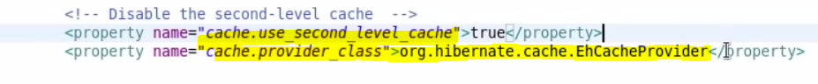

2. Download the ehcache.jar from their websites and add it to the class path of your project.

3. Define the Entities to be Cacheable.

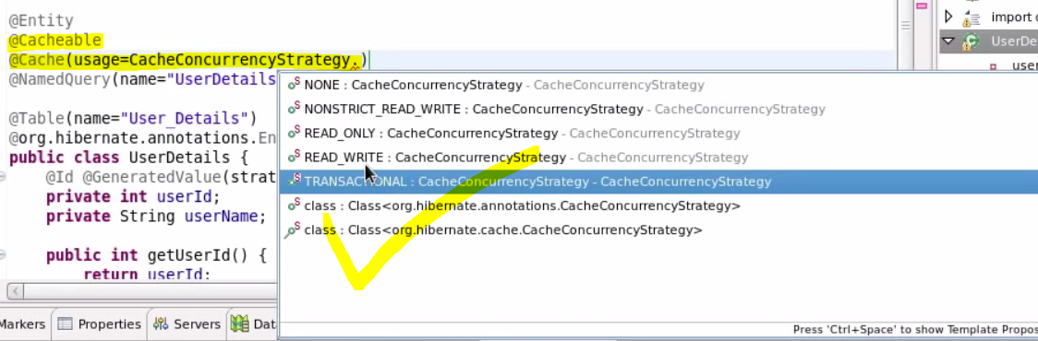

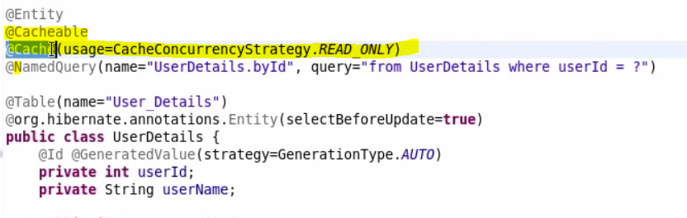

Now if we again run our third case(Two Different Session)



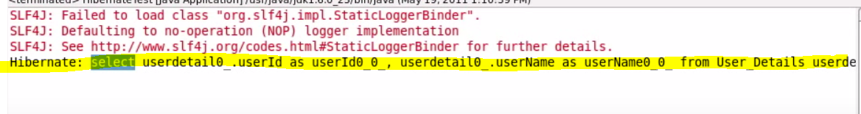

Here we can see that Hibernate execute it only once even though we are running session.get in two different sessions. That is because first session.get trigger select query. Second session.get did not find it in it’s session. So it will first look up this object in Second Level cache, It finds it there. So it picks up that object from there.

Note:- In case if hibernate does not find it even in second level cache, Hibernate will go to the database and load it from there.

1. **Query Level Cache:-**

What if we do not use session.get but use session.createQuery(). Here we are passing HQL in createQuery() which needs also to be cached.

**If Query Level Cache is not used:-**

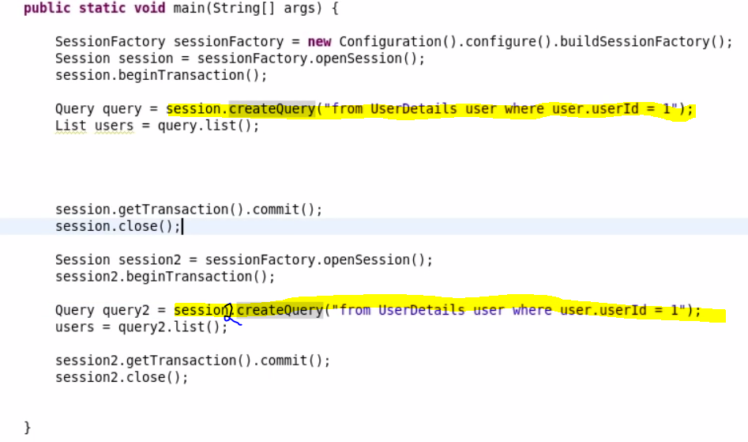

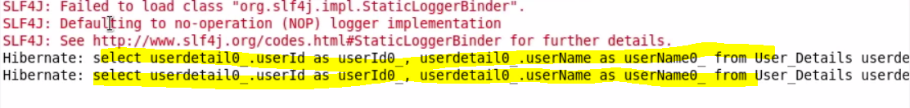

**Query Level Cache used:-** Below configuration needs to be done for enabling query level cache.

1. Enabling Query level cache in hibernate.cfg.xml file:-

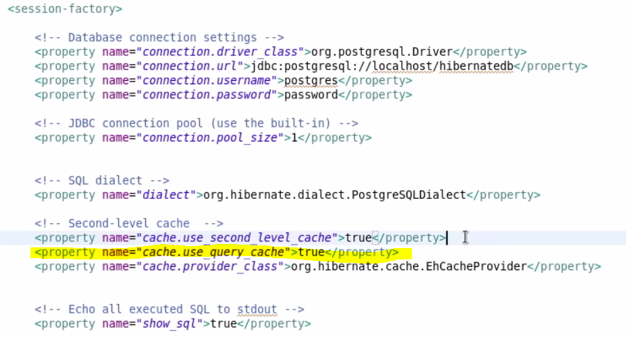

1. Setting cacheable true to the query.

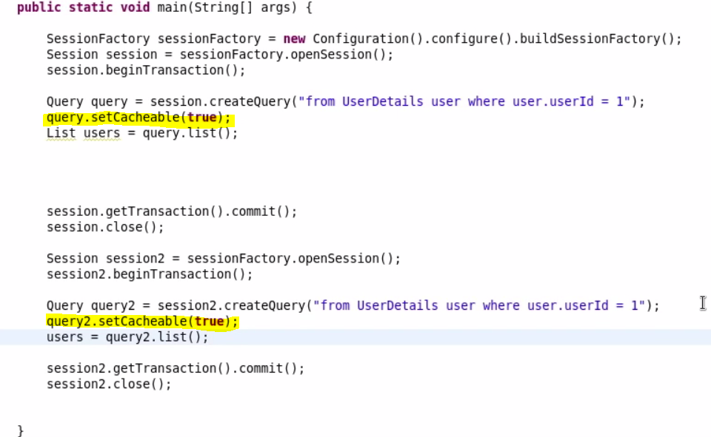

**Output:-**

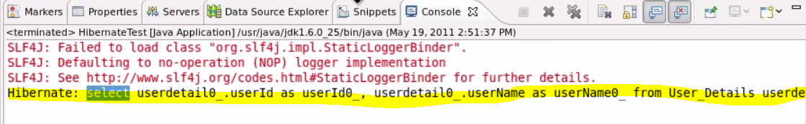

So first query.setCacheable(true) will put this object in cache and second query.setCacheable(true) call will look into second level cache and if it finds it there it will load the data with out going to database. If it does not find there, Hibernate will go to database and load it.

**Hibernate Interview Questions**

1. What is JDBC?

JDBC stands for Java Database Connectivity and provides a set of Java API for accessing the relational databases from Java program. These Java APIs enables Java programs to execute SQL statements and interact with any SQL compliant database.

1. What is ORM?

ORM stands for Object-Relational Mapping (ORM) is a programming technique for converting data between relational databases and object oriented programming languages such as Java, C# etc.

1. What are the advantages of ORM over JDBC?

* **Fast Performance:** The performance of hibernate framework is fast because cache is internally used in hibernate framework. There are two types of cache in hibernate framework first level cache and second level cache. First level cache is enabled by default.
* **Database Independent query:** HQL (Hibernate Query Language) is the object-oriented version of SQL. It generates the database independent queries. So you don't need to write database specific queries. Before Hibernate, if database is changed for the project, we need to change the SQL query as well that leads to the maintenance problem.
* **Automatic table creation:** Hibernate framework provides the facility to create the tables of the database automatically. So there is no need to create tables in the database manually.
* Let’s business code access objects rather than DB tables.

1. Name some of the ORM frameworks based on JAVA?

Enterprise JavaBeans Entity Beans, Spring DAO, Hibernate etc.

1. What is Hibernate?

Hibernate is an Object-Relational Mapping (ORM) solution for JAVA. It is a powerful, high performance Object-Relational Persistence and Query service for any Java Application. Hibernate maps Java classes to database tables and from Java data types to SQL data types and relieve the developer from 95% of common data persistence related programming tasks.

1. What are the advantages of using Hibernate?

* Hibernate takes care of mapping Java classes to database tables using XML files and without writing any line of code.
* Provides simple APIs for storing and retrieving Java objects directly to and from the database.
* If there is change in Database or in any table then the only need to change XML file properties.
* Abstract away the unfamiliar SQL types and provide us to work around familiar Java Objects.
* Manipulates Complex associations of objects of your database.

1. Name some of the java based tools/frameworks that supports hibernate integration.

Eclipse plug-ins, Maven, J2EE, XDoclet Spring etc.

1. What are the core interfaces of Hibernate? / What are the key components/objects of hibernate?

**Configuration -** Represents a configuration or properties file required by the Hibernate.

**SessionFactory -** Configures Hibernate for the application using the supplied configuration file and allows for a Session object to be instantiated.

**Session -** Used to get a physical connection with a database.

**Transaction -** Represents a unit of work with the database and most of the RDBMS supports transaction functionality.

**Query -** Uses SQL or Hibernate Query Language (HQL) string to retrieve data from the database and create objects.

**Criteria -** Used to create and execute object oriented criteria queries to retrieve objects.

1. What are the two key components of a hibernate configuration object?

The Configuration object provides two keys components:

**Database Connection:** This is handled through one or more configuration files supported by Hibernate. These files are hibernate.properties and hibernate.cfg.xml.

**Class Mapping Setup:** This component creates the connection between the Java classes and database tables.

1. What is a configuration object in hibernate?

The Configuration object is the first Hibernate object you create in any Hibernate application and usually created only once during application initialization. It represents a configuration or properties file required by the Hibernate.

1. What is a SessionFactory in hibernate?

Configuration object is used to create a SessionFactory object which in turn configures Hibernate for the application using the supplied configuration file and allows for a Session object to be instantiated. The SessionFactory is a thread safe object and used by all the threads of an application.

**Note:-** ThreadSafe means…the SessionFactory object’s state cannot be changed by any thread accessing it. It does not mean threads cant access simultaneously.  
Multiple threads can safely access a ThreadSafe object-SessionFactory.

The SessionFactory is heavyweight object so usually it is created during application start up and kept for later use. You would need one SessionFactory object per database using a separate configuration file. So if you are using multiple databases then you would have to create multiple SessionFactory objects.

SessionFactory provides the instance of Session. It is a factory of Session.

The internal state of a SessionFactory is immutable. Once it is created this internal state is set. This internal state includes all of the metadata about Object/Relational Mapping.

It holds the data of second level cache that is not enabled by default.

Session is thread-safe object.

1. What is Session in hibernate?

A Session is used to get a physical connection with a database. The Session object is lightweight and designed to be instantiated each time an interaction is needed with the database. Persistent objects are saved and retrieved through a Session object.

The session objects should not be kept open for a long time because they are not usually thread safe and they should be created and destroyed them as needed.

It is a factory of Query, Criteria and Transaction i.e. it provides factory methods to return these instances. This holds first level cache that is enabled by default.

Session is not a thread-safe object, many threads can access it simultaneously

1. What is Transaction in hibernate?

A Transaction represents a unit of work with the database and most of the RDBMS supports transaction functionality. This is an optional object and Hibernate applications may choose not to use this interface, instead managing transactions in their own application code.

Session.beginTransaction() method begins a unit of work and returns the associated Transaction object.

1. What is Query in hibernate?

Query objects use SQL or Hibernate Query Language (HQL) string to retrieve data from the database and create objects.

1. What is Criteria in hibernate?

Hibernate provides Criteria API that is more object oriented for querying the database and getting results. We can’t use Criteria to run update or delete queries or any DDL statements. It’s only used to fetch the results from the database using more object oriented approach.

Crietria c=session.createCriteria(Emp.class);

c.addOrder(Order.asc("salary"));

List list=c.list();

List employees = session.createCriteria(Employee.class)

.add(Restrictions.like("name", "a%") )

.add(Restrictions.like("address", "Boston"))

.addOrder(Order.asc("name") )

.list();

1. Name some of the properties you would require to configure for a databases in a standalone situation?

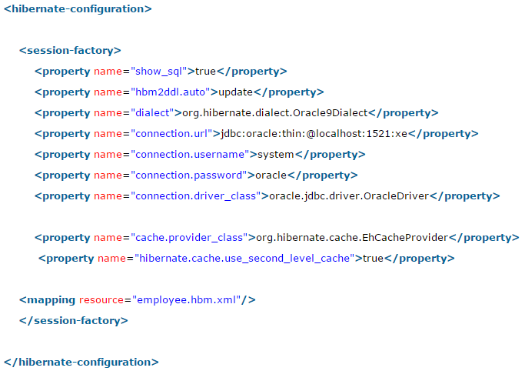

hibernate.dialect: This property makes Hibernate generate the appropriate SQL for the chosen database.

1. What are the three states of a persistent entity at a given point in time?

Instances may exist in one of the following three states at a given point in time:

**transient:** A new instance of a persistent class which is not associated with a Session and has no representation in the database and no identifier value is considered transient by Hibernate.

**persistent:** You can make a transient instance persistent by associating it with a Session. A persistent instance has a representation in the database, an identifier value and is associated with a Session.

**detached:** Once we close the Hibernate Session, the persistent instance will become a detached instance.

1. Which method is used to create a HQL query?

Session.createQuery() creates a new instance of Query for the given HQL query string.

1. Which method is used to create a SQL query?

Session.createSQLQuery() creates a new instance of SQLQuery for the given SQL query string.

1. Which method is used to remove a persistent instance from the datastore?

Session.delete() removes a persistent instance from the datastore.

1. Which method is used to get a persistent instance from the datastore?

Session.get() returns the persistent instance of the given named entity with the given identifier, or null if there is no such persistent instance.

1. Which method is used to re-read the state of the given instance from the underlying database?

Session.refresh() re-reads the state of the given instance from the underlying database.

1. Which method is used to save the state of the given instance from the underlying database?

Session.save()

1. Which method is used to update the state of the given instance from the underlying database?

Session.update()

1. Which method is used to save or update the state of the given instance from the underlying database?

Session.saveOrUpdate either saves(Object) or updates(Object) the given instance.

1. What persistent classes are in hibernate?

Java classes whose objects or instances will be stored in database tables are called persistent classes in Hibernate.

1. What are the best practices that hibernate recommends for persistent classes.

There are following main rules of persistent classes, however, none of these rules are hard requirements.

* All Java classes that will be persisted need a default constructor.
* All classes should contain an ID in order to allow easy identification of your objects within Hibernate and the database. This property maps to the primary key column of a database table.
* All attributes that will be persisted should be declared private and have getXXX and setXXX methods defined in the JavaBean style.

1. Where Object/relational mappings are defined in hibernate?

An Object/relational mappings are usually defined in an XML document. We should save the mapping document in a file with the format <classname>.hbm.xml.

1. Example of persistent class and it’s mapping?

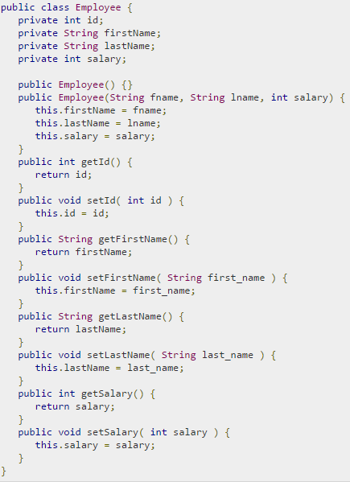 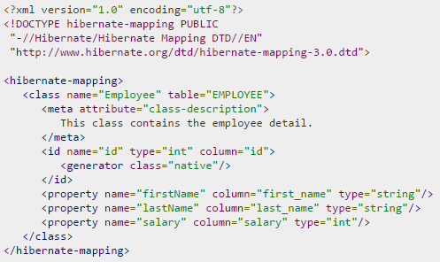

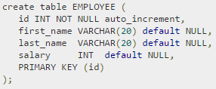

1. What is the difference between session.save() and session.persist() method?

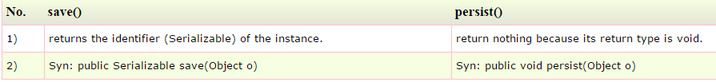

For Example:

System.out.println(session.save(aCoin)); - will print the generated primary key.

System.out.println(session.persist(aCoin)); - will throw a compile time error because persist()'s return type is void.

1. What is the difference between session.save() and session.saveOrUpdate() method?

* The main difference between save() and saveOrUpdate() method is that save() method performs an INSERT operation to store the object into the database, but INSERT will fail if the primary key is already persistent i.e. object already exists in the database. This is why, you should only call save() with an absolutely new object which doesn't have any database identifier. Calling save() with the detached object will fail. This is opposite of saveOrUpdate() method, which can do either INSERT or UPDATE SQL query depending upon whether an object exists in the database or not. The saveOrUpdate() method first executes a SELECT query to determine if it needs to do an INSERT or UPDATE operation.
* Another key difference between save() and saveOrUpdate() method is that former is used to bring a transient object to persistent state but saveOurUpdate() can bring both transient (new) and detached (existing) object into persistent state. It is often used to re-attach a detached object into Session.

1. What is the difference between get and load method?

session.load() –

* It will always return a “proxy” (Hibernate term) without hitting the database. In Hibernate, proxy is an object with the given identifier value, its properties are not initialized yet, it just look like a temporary fake object.
* If no row found, it will throws an ObjectNotFoundException.

session.get() –

* It always hit the database and return the real object, an object that represent the database row, not proxy.
* If no row found, it return null.

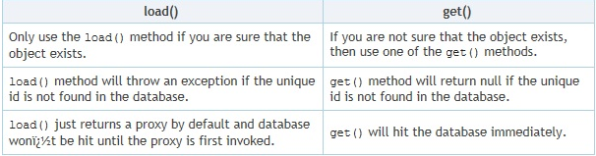

**Point#1 Session.load() is better performant Example** in a Stock application , Stock and StockTransactions should have a “one-to-many” relationship, when you want to save a stock transaction, it’s common to declared something like below.

**Session.get():**In session.get(), Hibernate will hit the database to retrieve the Stock object and put it as a reference to StockTransaction. However, this save process is extremely high demand, there may be thousand or million transactions per hour, do you think is this necessary to hit the database to retrieve the Stock object everything save a stock transaction record? After all you just need the Stock’s Id as a reference to StockTransaction.

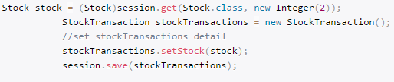 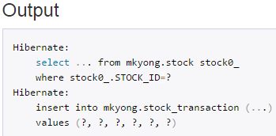

**Session.load():** **session.load()** will be your good solution.

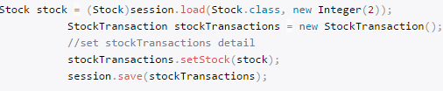 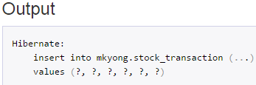

In session.load(), Hibernate will not hit the database (no select statement in output) to retrieve the Stock object, it will return a Stock proxy object – a fake object with given identify value. In this scenario, a proxy object is enough for to save a stock transaction record.

**Point#2 Exception case**

session.load() - It will always return a proxy object with the given identity value, even the identity value is not exists in database. However, when you try to initialize a proxy by retrieve it’s properties from database, it will hit the database with select statement. If no row is found, **ObjectNotFoundException** will throw.

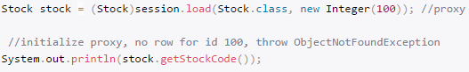 

session.load() - It will always return null , if the identity value is not found in database.

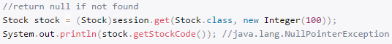

1. What is the difference between update and merge method?

At first look both update() and merge() methods seems similar because both of them are used to convert the object which is in detached state into persistence state but there are some differences as well.

* update() and merge() both methods are used to update the db row if it already exist. But if object does not exist in db already then the update() method will throw the exception while merge() will create the new entry in db for that object.
* If session does not contains an already persistent instance with the same identifier and if you are sure about that then use update to save the data. But merge() method can save your modifications at any time with out having the knowledge about the state of session.

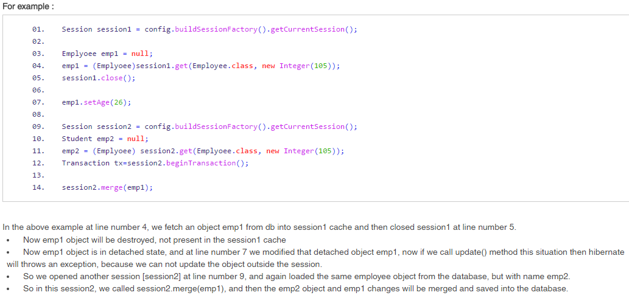

1. What is difference between openSession and getCurrentSession?

Hibernate SessionFactory getCurrentSession() method returns the session bound to the context. But for this to work, we need to configure it in hibernate configuration file. Since this session object belongs to the hibernate context, we don’t need to close it. Once the session factory is closed, this session object gets closed.



Hibernate SessionFactory openSession() method always opens a new session. We should close this session object once we are done with all the database operations. We should open a new session for each request in multi-threaded environment.

1. What is SessionFactory.openStatelessSession?

* Hibernate SessionFactory openStatelessSession() method returns instance of StatelessSession. There is another overloaded method where we can pass java.sql.Connection object to get a stateless session object from hibernate.
* StatelessSession in Hibernate does not implement first-level cache and it doesn’t interact with any second-level cache. Collections are also ignored by a stateless session.
* However, stateless session can be a good fit in certain situations. For example where we are loading bulk data into database and we don’t want hibernate session to hold huge data in first-level cache memory.

1. What is lazy loading?

Lazy loading is a technique in which objects are loaded on demand basis. Since Hibernate 3, lazy loading is by default, enabled so that child objects are not loaded when parent is loaded. Lazy collection loads the child objects on demand, it is used to improve performance.

To use lazy collection, you may optionally use lazy="true" attribute in your collection. It is by default true, so you don't need to do this. If you set it to false, all the child objects will be loaded initially which will decrease performance in case of big data.

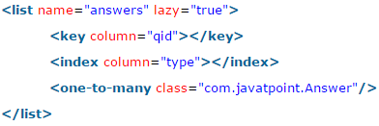

1. What is caching in hibernate?

Caching is all about application performance optimization and it sits between your application and the database to avoid the number of database hits as many as possible to give a better performance for performance critical applications.

Caching is important to Hibernate as well which utilizes a multilevel caching schemes as explained below:

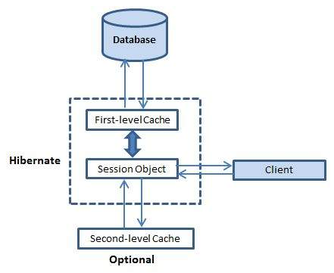

**First-level cache:**

The first-level cache is the Session cache and is a mandatory cache through which all requests must pass. The Session object keeps an object under its own power before committing it to the database.

If you issue multiple updates to an object, Hibernate tries to delay doing the update as long as possible to reduce the number of update SQL statements issued. If you close the session, all the objects being cached are lost and either persisted or updated in the database.

Hibernate first level cache is associated with the Session object. Hibernate first level cache is enabled by default and there is no way to disable it. However hibernate provides methods through which we can delete selected objects from the cache or clear the cache completely.

**Second-level cache:**

Second level cache is an optional cache and first-level cache will always be consulted before any attempt is made to locate an object in the second-level cache. The second-level cache can be configured on a per-class and per-collection basis and mainly responsible for caching objects across sessions.

Any third-party cache can be used with Hibernate. An **org.hibernate.cache.CacheProvider** interface is provided, which must be implemented to provide Hibernate with a handle to the cache implementation.

**SessionFactory** holds the second level cache data. It is global for all the session objects and not enabled by default.

Different vendors have provided the implementation of Second Level Cache.

EH Cache

OS Cache

Swarm Cache

JBoss Cache

**Concurrency or Caching strategies:**

There are some caching strategies which you have to keep in mind when using a second-level cache:

* **Read Only** This strategy should be used for persistent objects that will be never updated. It is good for reading and caching application configuration and other static data. This is the simplest strategy with best performance because there is no overload to check if an entity is updated in database or not.
* **Read-Write** This strategy is good for entities which are updated by the application. However if the data is updated either through the database or other applications, then there is no way Hibernate could tell if there was a change or not and your data might be stale.
* **Nonrestricted Read-Write** If the application only occasionally updates data and strict transaction isolation is not required, this caching strategy might be appropriate.
* **Transactional** This caching strategy provides support for fully transactional cache providers such as JBoss TreeCache. Such a cache can only be used in a JTA environment and you must specify transaction.manager_lookup_class.

**3 extra steps for second level cache example using EH cache**

* Add 2 configuration setting in hibernate.cfg.xml file



* Add cache usage setting in hbm file

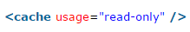

* Create ehcache.xml file

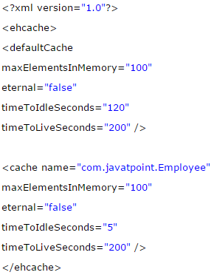

**Query-level cache:**

Hibernate also implements a cache for query resultsets that integrates closely with the second-level cache.

This is an optional feature and requires two additional physical cache regions that hold the cached query results and the timestamps when a table was last updated. This is only useful for queries that are run frequently with the same parameters.

To use the query cache, you must first activate it using the **hibernate.cache.use_query_cache="true"** property in the configuration file. By setting this property to true, you make Hibernate create the necessary caches in memory to hold the query and identifier sets.

Next, to use the query cache, you use the **setCacheable(Boolean)** method of the Query class. For example:

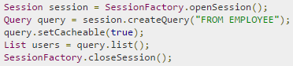

Hibernate also supports very fine-grained cache support through the concept of a cache region. A cache region is part of the cache that's given a name.

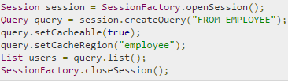

This code uses the method to tell Hibernate to store and look for the query in the employee area of the cache.

1. What will happen if we don’t have no-args constructor in Entity bean?

Hibernate uses Reflection API to create instance of Entity beans, usually when you call get() or load() methods. The method Class.newInstance() is used for this and it requires no-args constructor. So if you won’t have no-args constructor in entity beans, hibernate will fail to instantiate it and you will get HibernateException.

1. What is difference between sorted collection and ordered collection, which one is better?

When we use Collection API sorting algorithms to sort a collection, it’s called sorted list. For small collections, it’s not much of an overhead but for larger collections it can lead to slow performance and OutOfMemory errors. Also the entity beans should implement Comparable or Comparator interface for it to work, read more at java object list sorting.

If we are using Hibernate framework to load collection data from database, we can use it’s Criteria API to use “order by” clause to get ordered list. Below code snippet shows you how to get it.

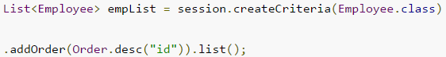

Ordered list is better than sorted list because the actual sorting is done at database level, that is fast and doesn’t cause memory issues.

1. Why we should not make Entity Class final?

Hibernate use proxy classes for lazy loading of data, only when it’s needed. This is done by extending the entity bean, if the entity bean will be final then lazy loading will not be possible, hence low performance.

1. Can we execute native sql query in hibernate?

Yes. For Hibernate Native SQL Query, we use Session.createSQLQuery(String query) to create the SQLQuery object and execute it. For example, if you want to read all the records from Employee table, we can do it through below code.

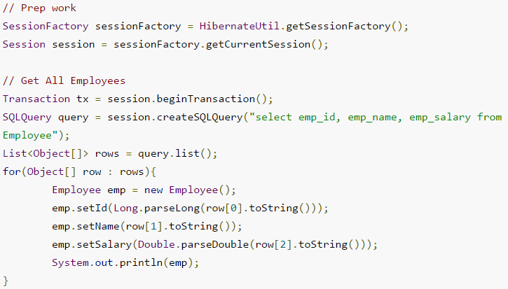

1. How to log hibernate generated sql queries in log files?

We can set below property for hibernate configuration to log SQL queries.



However we should use it only in Development or Testing environment and turn it off in production environment.

1. What is Named SQL Query?

Hibernate provides Named Query that we can define at a central location and use them anywhere in the code. We can created named queries for both HQL and Native SQL.

Hibernate Named Queries can be defined in Hibernate mapping files or through the use of JPA annotations @NamedQuery and @NamedNativeQuery.

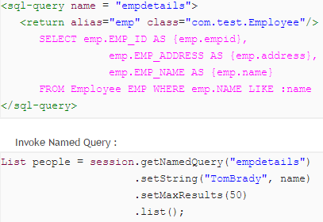

1. What are the benefits of Named SQL Query?

* Hibernate Named Query helps us in grouping queries at a central location rather than letting them scattered all over the code.
* Hibernate Named Query syntax is checked when the hibernate session factory is created, thus making the application fail fast in case of any error in the named queries.
* Hibernate Named Query is global, means once defined it can be used throughout the application.

However one of the major disadvantage of Named query is that it’s hard to debug, because we need to find out the location where it’s defined.

1. What is Hibernate Proxy and how it helps in lazy loading?

Hibernate uses proxy object to support lazy loading. Basically when you load data from tables, hibernate doesn’t load all the mapped objects. As soon as you reference a child or lookup object via getter methods, if the linked entity is not in the session cache, then the proxy code will go to the database and load the linked object. It uses javassist to effectively and dynamically generate sub-classed implementations of your entity objects.

1. How transaction management works in Hibernate?

Transaction management is very easy in hibernate because most of the operations are not permitted outside of a transaction. So after getting the session from SessionFactory, we can call session beginTransaction() to start the transaction. This method returns the Transaction reference that we can use later on to either commit or rollback the transaction.

1. How to integrate log4j logging in hibernate application?

Hibernate 4 uses JBoss logging rather than slf4j used in earlier versions. For log4j configuration, we need to follow below steps.

* Add log4j dependencies for maven project, if not maven then add corresponding jar files.
* Create log4j.xml configuration file or log4j.properties file and keep it in the classpath. You can keep file name whatever you want because we will load it in next step.
* For standalone projects, use static block to configure log4j using DOMConfigurator or PropertyConfigurator. For web applications, you can use ServletContextListener to configure it.

That’s it, our setup is ready. Create org.apache.log4j.Logger instance in the java classes and start logging.

1. How to use application server JNDI DataSource with Hibernate framework?

For web applications, it’s always best to allow servlet container to manage the connection pool. That’s why we define JNDI resource for DataSource and we can use it in the web application. It’s very easy to use in Hibernate, all we need is to remove all the database specific properties and use below property to provide the JNDI DataSource name.



<http://www.journaldev.com/2905/hibernate-tomcat-jndi-datasource-example-tutorial>

1. How to integrate Hibernate with Servlet or Struts2 web applications?

Hibernate integration with Servlet or Struts2 needs to be done using ServletContextListener.

1. Should all the mapping files of hibernate have .hbm.xml extension to work properly?

No, having .hbm.xml extension is a convention and not a requirement for hibernate mapping file names. We can have any extension for these mapping files.

1. How do you invoke Stored Procedures?

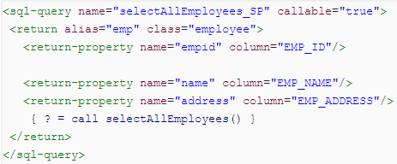

1. Which design patterns are used in Hibernate framework?

Some of the design patterns used in Hibernate Framework are:

* Domain Model Pattern – An object model of the domain that incorporates both behavior and data.
* Data Mapper – A layer of Mappers that moves data between objects and a database while keeping them independent of each other and the mapper itself.
* Proxy Pattern - for lazy loading
* Factory pattern - in SessionFactory

1. What are best practices to follow with Hibernate framework?

* Use native sql query only when it can’t be done using HQL, such as using database specific feature.
* If you have to sort the collection, use ordered list rather than sorting it using Collection API.
* Use named queries wisely, keep it at a single place for easy debugging. Use them for commonly used queries only. For entity specific query, you can keep them in the entity bean itself.
* For web applications, always try to use JNDI DataSource rather than configuring to create connection in hibernate.
* For collections, try to use Lists, maps and sets. Avoid array because you don’t get benefit of lazy loading.
* Do not treat exceptions as recoverable, roll back the Transaction and close the Session. If you do not do this, Hibernate cannot guarantee that in-memory state accurately represents the persistent state.
* Prefer DAO pattern for exposing the different methods that can be used with entity bean
* Prefer lazy fetching for associations.

1. How do you define sequence generated primary key in hibernate?

Using <generator> tag.

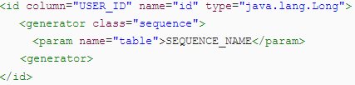

1. How can a whole class be mapped as immutable?

Mark the class as mutable="false" (Default is true). This specifies that instances of the class are (not) mutable. Immutable classes, means the updates to this class will be ignored, but no exception is thrown, only the add and delete operation are allow.

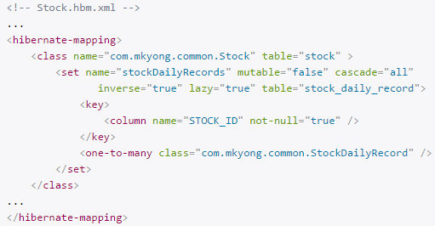

1. What is automatic dirty checking?

Automatic dirty checking is a feature that saves us the effort of explicitly asking Hibernate to update the database when we modify the state of an object inside a transaction.

1. What are Callback interfaces?

Callback interfaces allow the application to receive a notification when something interesting happens to an object—for example, when an object is loaded, saved, or deleted. Hibernate applications don't need to implement these callbacks, but they're useful for implementing certain kinds of generic functionality.

1. How can Hibernate be configured to access an instance variable directly and not through a setter method?

By mapping the property with access="field" in Hibernate metadata. This forces hibernate to bypass the setter method and access the instance variable directly while initializing a newly loaded object.

1. What are the types of inheritance models in Hibernate?

We can map the inheritance hierarchy classes with the table of the database. There are three inheritance mapping strategies defined in the hibernate:

**Table Per Hierarchy:** In table per hierarchy mapping, single table is required to map the whole hierarchy, an extra column (known as discriminator column) is added to identify the class. But nullable values are stored in the table.

**Table Per Concrete class:** In case of table per concrete class, tables are created as per class. But duplicate column is added in subclass tables.

**Table Per Subclass:** In this strategy, tables are created as per class but related by foreign key. So there are no duplicate columns.

1. What are the Collection types in Hibernate?

Bag

Set

List

Array

Map

1. How can we get hibernate statistics?

We can get hibernate statistics using getStatistics() method of SessionFactory class as shown below:  
SessionFactory.getStatistics()

1. What’s the use of session.lock() in hibernate?

session.lock() method of session class is used to reattach an object which has been detached earlier. This method of reattaching doesn’t check for any data synchronization in database while reattaching the object and hence may lead to lack of synchronization in data.

1. What is cascading and what are different types of cascading?
2. How to implement relationships in hibernate?

We can easily implement one-to-one, one-to-many and many-to-many relationships in hibernate. It can be done using JPA annotations as well as XML based configurations. For better understanding, you should go through following tutorials.